**CCNA Review Exercise**

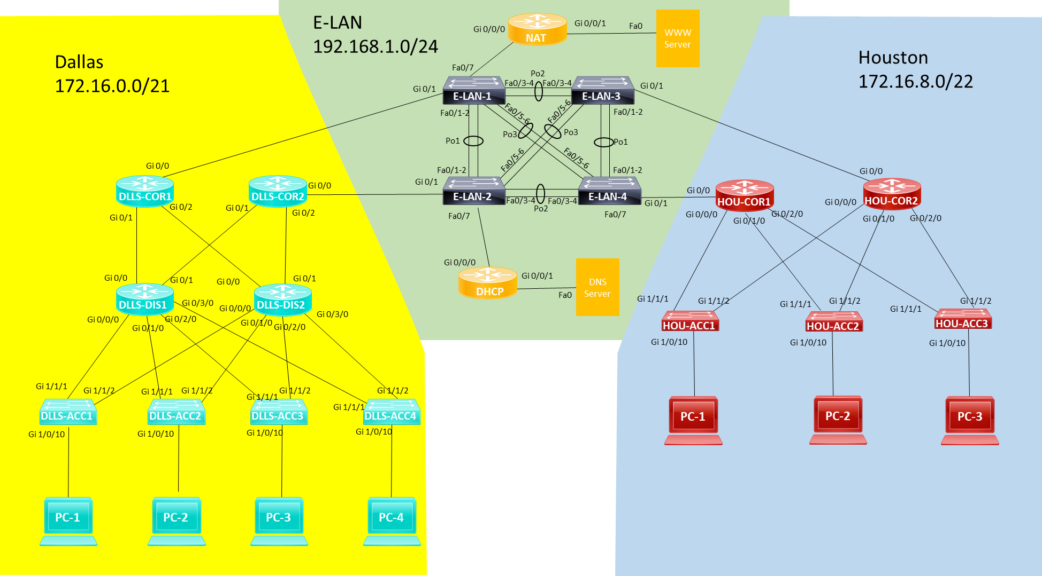

You are tasked with building the above network.

Dallas is a 3-tier network

Houston is a 2-tier network

Both sites connect to a datacenter that uses E-LAN for Connectivity

**E-LAN Configuration**

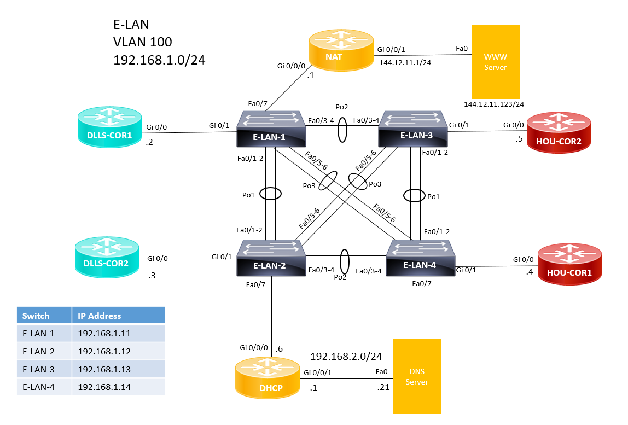

All switchports between switches shall be static trunk links.

EtherChannel configurations shall be statically configured.

E-LAN-1 should be the root bridge for all VLANs. Use 4096 for priority.

Only VLAN’s 99 and 100 are allowed across trunks.

|  |  |
| --- | --- |
| **VLAN** | **Name** |
| 99 | native |
| 100 | CORE |

Switchports connected to routers and end devices shall be configured to forward traffic immediately after connected.

Ensure all Switches are reachable from all networks.

**NAT will need to be configured to support outgoing access to the web server (**[**www.cisco.com**](http://www.cisco.com)**)**

Dynamic Nat with PAT will be used to forward traffic out the interface to the Web Server

Create Access-list 1 to identify addresses to be translated.

ACL 1 shall have only two entries

First entry to specify all traffic from 172.16.x.x

Second entry to specify all traffic from 192.168.1.x

Do not use a pool for NAT translation.

**Create DHCP Pools using the following format. DLLS_VLAN_10**

Be sure to include default gateway and DNS Server information in all pools.

Exclude addresses 1-5 in all pools.

**Dallas Configuration**

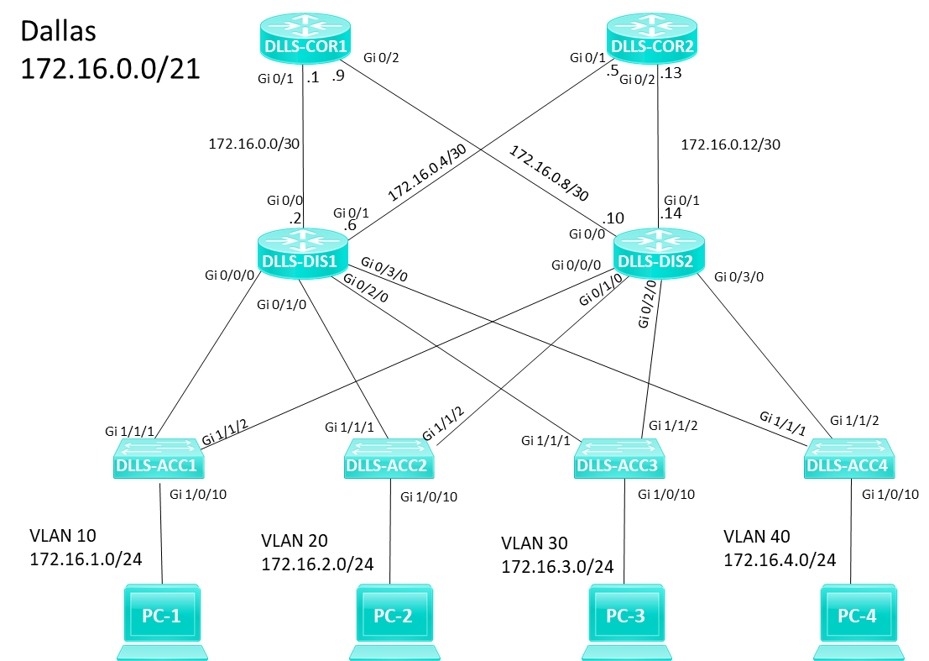

OSPF Area 0 will be used for the entire network.

Network statements will be used for OSPF.

Passive interfaces should be used whenever possible.

**Connections between CORE routers shall be multiaccess.**

DLLS-COR1 shall be DR, it shall have the highest possible priority.

DLLS-COR2 shall be BDR, it shall have a priority one lower than COR1.

Connections between COR and DIS routers shall be point-to-point.

**HSRP will be used for all LANS, Ensure COR1 is Active**

DIS1 interfaces should use the second ip address of the network.

DIS2 interfaces should use the third ip address of the network.

The Virtual address of the network should be first address of the network.

Switch SVI’s should be the 5th address of the network.

**All routers will need loopback addresses configured within the available address space for site.**

|  |  |
| --- | --- |
| **Hostname** | **Loopback Address** |
| DLLS-COR1 | 172.16.0.16/32 |
| DLLS-COR2 | 172.16.0.17/32 |
| DLLS-DIS1 | 172.16.0.18/32 |
| DLLS-DIS2 | 172.16.0.19/32 |

Switchports connected to routers and end devices shall be configured to forward traffic immediately after connected.

**Houston Configuration**

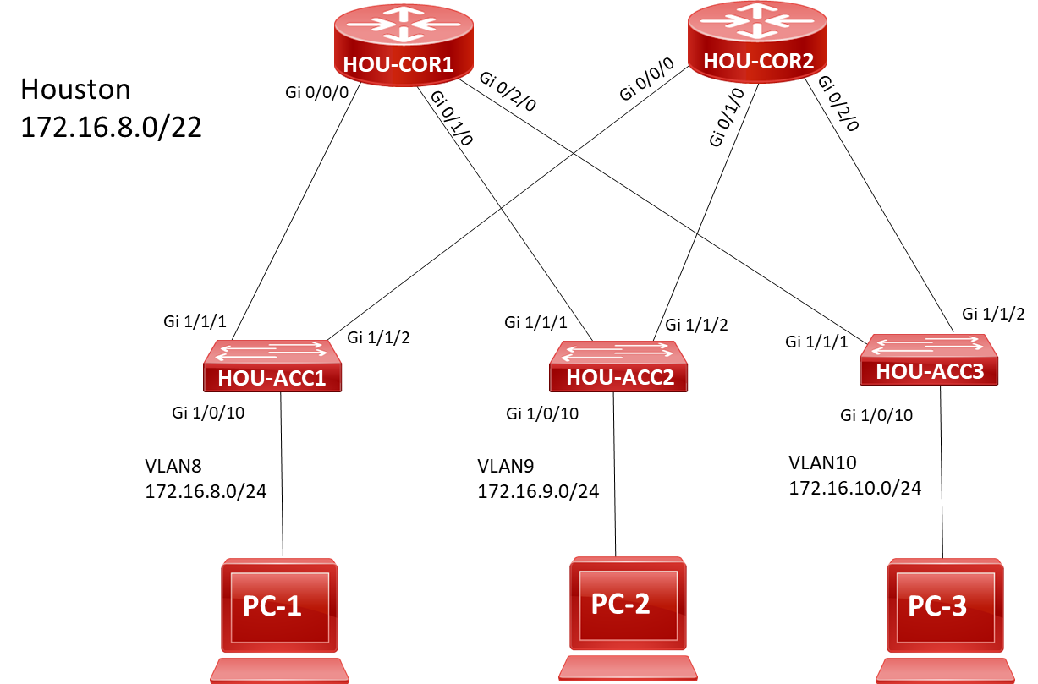

OSPF Area 0 will be used for the entire network.

Connections between CORE routers shall be multiaccess.

Interface configuration shall be used for OSPF configuration.

Passive interfaces should be used whenever possible.

**All routers will need loopback addresses configured within the available address space for site.**

|  |  |
| --- | --- |
| **Hostname** | **Loopback Address** |
| HOU-COR1 | 172.16.11.1/32 |
| HOU-COR2 | 172.16.11.2/32 |

**HSRP will be used for all LANs, Ensure COR1 is Active**

DIS1 interfaces should use the second ip address of the network.

DIS2 interfaces should use the third ip address of the network.

The virtual address of the network should be first address of the network.

Switch SVI’s should be the 5th address of the network.

Switchports connected to routers and end devices shall be configured to forward traffic immediately after connected.